Relaxa Software Development Plan

Version <1.1>

**Prepared by**

**Israt Zerin Tisha(16511013), Md.Ata-E-Rabbi(16511021),**

**Md.Minhazul Abedin(16511024), Tazqia Mehrub(16511041),**

**Sharmeen Jahan Seema(16511080)**

**4 October, 2018**

**Contents**

**1. Software Development Plan**

**Introduction** . . . . . . . . . . . . . . . . . . . . . . . . . . . . . . . . . . . . . . . . . . . . . . . . 1

1.1 Purpose . . . . . . . . . . . . . . . . . . . . . . . . . . . . . . . . . . . . . . . . . . . . . 1

1.2 Document History . . . . . . . . . . . . . . . . . . . . . . . . . . . . . . . . . . . . .1

1.3 Targeted User. . . . . . . . . . . . . . . . . . . . . . . . . . . . . . . . . . . . . . . .1

1.4 Product Scope . . . . . . . . . . . . . . . . . . . . . . . . . . . . . . . . . . . . . . . .1-3

1.5 Process Model . . . . . . . . . . . . . . . . . . . . . . . . . . . . . . . . . . . . . . . .3

1.6 Method, Tools and Techniques . . . . . . . . . . . . . . . . . . . . . . . . . . .3

1.7 Plan and timing . . . . . . . . . . . . . . . . . . . . . . . . . . . . . . . . . . . . . . . 3

1.8 Deliverables . . . . . . . . . . . . . . . . . . . . . . . . . . . . . . . . . . . . . . . . . . 3

1.9 Testing . . . . . . . . . . . . . . . . . . . . . . . . . . . . . . . . . . . . . . . . . . . . . . . 3

**2. Business Plan**

**2.1** The Management Team . . . . . . . . . . . . . . . . . . . . . . . . . . . . . . . . . . . . 4

**2.2** The Opportunity . . . . . . . . . . . . . . . . . . . . . . . . . . . . . . . . . . . . . . . . . 4

**2.3** The Investment Offering . . . . . . . . . . . . . . . . . . . . . . . . . . . . . . . . . . . 4

**Use Case Diagram**

Level 0 . . . . . . . . . . . . . . . . . . . . . . . . . . . . . . . . . . . . . . . . . . . . . . . . . 5

Level 1 . . . . . . . . . . . . . . . . . . . . . . . . . . . . . . . . . . . . . . . . . . . . . . . . . 6

Level 2 . . . . . . . . . . . . . . . . . . . . . . . . . . . . . . . . . . . . . . . . . . . . . . . . . 7

**Activity Diagram** . . . . . . . . . . . . . . . . . . . . . . . . . . . . . . . . . . . . . . . . . . . . . 8

**Data Modeling** . . . . . . . . . . . . . . . . . . . . . . . . . . . . . . . . . . . . . . . . . . . . . .11

**Entity Relationship Model** . . . . . . . . . . . . . . . . . . . . . . . . . . . . . . . . . . . .12

**1. Introduction**

**1.1 Purpose**

The Software Development Plan is a comprehensive, composite artifact that gathers all information required to manage the project. It encloses a number of artifacts developed during the Inception phase and is maintained throughout the project. The purpose of this document is to present a detailed description of the software ‘Relaxa’ and gathering all the information necessary to control the project. It will explain the purpose, features, planning and procedures of the software. This document is intended for the users of the software and also potential developers.

## 1.2 Document History

|  |  |  |  |
| --- | --- | --- | --- |
| **Version** | **Date** | **Author(s)** | **Comment/Summary of Updates** |
| 1.0 | 12 July, 2018 | Israt Zerin Tisha  Md.Ata-E-Rabbi  Md.Minhazul Abedin  Tazqia Mehrub  Sharmeen Jahan Seema |  |
| 1.1 | 4 October,2018 | Israt Zerin Tisha  Md.Ata-E-Rabbi  Md.Minhazul Abedin  Tazqia Mehrub  Sharmeen Jahan Seema |  |

**1.3 Targeted user**

* Typical users, such as “android app user”, they can use this software relaxation from

stress and depression. There will be suggestions for relaxation by reading the mementos, listening to music, reading inspiring stories, chatting with a bot, making a health plan, taking help from a habit-maker by reminding and suggesting, setting a goal from suggestions.

* Programmers who are interested in working on the project by further developing it.

**1.4 Product scope**

Relaxa is a software which is created because we know how difficult and personal anxiety can be. This software can be used for self-help.

Firstly, the user gets some questions to detect whether he/she is suffering from depression. After getting the answers from the user the software will suggest:

i. Create Memento

ii. Songs, Inspiring stories

iii. Chatbot

iv. Habit maker, Try out something new

v. Health

vi. Set a goal

Secondly, the user can choose any of them. The software saves images and stories of as memento which can be viewed by the user later on.

Thirdly, the software can give reminders for setting goals and making new habits to get out of depression.

Fourthly, the software lets the user to chat with a bot.

Fifthly, the software provides the user with songs and music. It also provides interesting and inspirational stories for reading.

Sixthly, the software provides the user with diet plans and physical exercise suggestions.

***Start Test Module***

The user has to click the ‘Start test’ button. After clicking start button it will provide eight questions for identifying the state of the user. If the user successfully answers all the questions, a suggestion menu will pop. The suggestion menu consists of:

i. Create Memento

ii. Songs, Inspiring stories

iii. Chatbot

iv. Habit maker, Try out something new

v. Health

vi. Set a goal

***Create Memento Module***

The user has to select the ‘Create Memento’ option. After clicking ‘Create Memento’ button the user can add image and stories beside each image. Then the user needs to save the moments. The user can view or edit the saved memento anytime.

***Songs, Inspiring Stories Module***

The user has to select the ‘Songs, Inspiring Stories’ option. After clicking ‘Songs, Inspiring Stories’ button the user can choose:

i. Listen to songs or music

ii. Read inspiring stories

***Chatbot Module***

The user has to select the ‘Chatbot’ option. The user can have a conversation with the chatbot.

***Habit-Maker, Try out Something New Module***

The user has to select the ‘Habit maker, Try out something new’ option. After clicking ‘Habit-maker, Try out something new’ the user can choose:

i. Make a habit

ii. Try out something new

After selecting ‘Make a habit’ button, the user can set a habit that he wants make and will get reminder for it.

After selecting ‘Try out something new’ button, the user will get a list of new ideas.

***Health Module***

The user has to select the ‘Health’ option. After clicking ‘Health’ the user can choose:

i. Diet

ii. Exercise

If the user selects ‘diet’, the user can get ideas about proper diet. The user can also set his own diet chart.

If the user selects ‘exercise’ button, the user will get a list of different physical exercises.

***Set a Goal Module***

The user has to select the ‘Set a Goal’ option. After clicking ‘Set a Goal’ button, the user can get:

i. Goal ideas

ii. Set a goal

The user will get reminder for it

**1.5 Process Model**

Software life-cycle model to be used is the Agile method of software development to create this software.

Specifications are written and the requirements of the project has been gathered.

The MVP(Model View Pattern) model has been used.

**1.6 Method, Tools and Techniques**

* Agile method of software development has been used.
* Object-oriented design will be used in developing this software.
* Source code will be written in Java and run under Android on an android mobile phone.
* Documentation and coding will be done according to the company standards.

The followings will be used to develop the software:

* Android Studio
* Microsoft Bot Framework
* Google Cognitive service
* Recommendation System
* Dagger 2 and Butterknife
* Google Play Service

| **Item** | **Applied for** | **Availability by** |
| --- | --- | --- |
| **Methods** |  |  |
| Use Case | Requirements capturing | M0 |
|  |  |  |
|  |  |  |
| **Tools** |  |  |
| Draw.io | Design | M2 |
|  |  |  |
|  |  |  |
| **Languages** |  |  |
| UML | Design | M2 |
| Java | Web interface | M2 |
|  | … | M2 |
|  |  |  |

**1.7 Plan and timing**

|  |  |
| --- | --- |
| Weeks | Task Description |
| Week 1 | Software Development Planning |
| Week 2 | Business Planning |
| Week 3 | Software Development and coding |
| Week 4 | Coding and Internal Interface Designing |
| Week 5 | External Interface Designing |

**1.8 Deliverables**

The following items are delivered at the end of the process:

* [use cases](https://en.wikipedia.org/wiki/Use_case)
* [class diagrams](https://en.wikipedia.org/wiki/Class_diagram)
* [Unified Modeling Language](https://en.wikipedia.org/wiki/Unified_Modeling_Language) (UML) models
* Entity Relation Diagram
* Swimlane Diagram
* Class Relation Collaboration
* Data Flow Diagram
* requirements and design documents
* Software and its configuration files
* Business Plan

**3.1 User stories:**

‘Relaxa ‘ is an apps for people who have depressive disorder based on cognitive behavioral therapy to manage their mental health with tools like mood and health tracking .

At first the users will enter the app and eight question will be set for the user-based on psychological research about depression to detect the user level of depression . Users will read the question and give answer to the question selecting “yes “ or “ no” only .

Their given answer will be evaluated as such:

1. If the no. of yes is counted between 1 to 3 , they will be categorized minor sufferer .

2. If the no. of yes is counted between 3 to 5 , they will be categorized medium sufferer .

3. If the no. of yes is counted between 5 to 8 , they will be categorized major sufferer .

The questions answered will be used to measure users’ well-being and screen for symptoms of depression, the app seeks to increase users’ awareness and understanding of their thoughts and feelings .They will be suggested to spend some of their time doing various activities which may cause their mood to swing. Memento section, listening music, chatbot, diet plan, setting goal – are the main features of the app , these features will be presented according to their level of depression.

The people who are categorized as minor sufferer will be suggested to listen some soothing music. There will be a memento section where they can personalize their note with their memorable moment of life which may make them feel good .get a diet chart and physical exercise routine which will be helpful to add some variation in their life.

The medium sufferer will also get the suggestion to listen music that may feel good to them. There will be a chatbot also. Those who feel lonely, can chat with it also. There will be a section named “Set a goal or try out something “ they can set their goal, for which they will get reminder or to try something new for variations

The major sufferers will be suggested to do the above tasks and also will be suggested with the following to go on a tour.

The user has to click the ‘Start test’ button. Start button it will provide eight questions for identifying the state of the user. If the user successfully answers all the questions, a suggestion menu will pop. The suggestion menu consists of:

i. Create Memento

ii. Songs, Inspiring stories

iii. Chatbot

iv. Health

v.Set a goal , try out something new

The user has to select the ‘Create Memento’ option. After clicking ‘Create Memento’ button the user can add image and stories beside each image. Then the user needs to save the moments. The user can view or edit the saved memento anytime.

The user has to select the ‘Songs’ option. After selecting ‘Songs’ button the user can choose from the listen to songs or music. In future, the user’s previous choice will be used to recommend music or songs.

The user can also select the ‘Chatbot’ option. The user can have a conversation with the chatbot.

The user can select the ‘Set a Goal’ option. After clicking ‘Set a Goal’ button, the user can get:

i. Goal ideas

ii. Set a goal

After selecting ‘Try out something new’ button, the user will get a list of new ideas to try out new things.

The user can also select the ‘Health’ option. After clicking ‘Health’ the user can choose:

i. Diet

ii. Exercise

If the user selects ‘diet’, the user can get ideas about proper diet. The user can also set his own diet chart. If the user selects ‘exercise’ button, the user can get ideas about physical exercise.

**3.2 Use Cases:**

**3.2.1 Use case for memento**

|  |  |
| --- | --- |
| Use case | Memento |
| Use case no | 1.1 |
| Primary actor | The user |
| description | Offer the users to personalize the notebook with this chosen memory ( image) or person (save contact ) |
| Precondition | None |
| Trigger | View his golden moments |
|  |  |

**3.2.2 Use case for songs and stories**

|  |  |
| --- | --- |
| Use case | Songs and Stories |
| Use case no | 1.2 |
| Primary actor | The user |
| description | Offer the users to listen some soothing music .also recommend music from previous record .The user can read stories |
| Precondition | The given question have to be answered |
| Trigger | Listen up the mind refreshing music and read stoires |
|  |  |

**3.2.3 Use case for chatbot**

|  |  |
| --- | --- |
| Use case | chatbot |
| Use case no | 1.3 |
| Primary actor | The user |
| description | Offer the users to chat with it |
| Precondition | The given question have to be answered |
| Trigger | Start to gossip with the users in a friendly manner. |
|  |  |

**3.2.4 Use case for Set a goal or try out something new**

|  |  |
| --- | --- |
| Use case | Set a goal or try something new |
| Use case no | 1.4 |
| Primary actor | The user |
| description | Offer the users to- i. set a goal option , after clicking it they can set their goal and will get reminder about it  ii. try something new , after clicking it , they will be suggested to try different things to overcome monotony . |
| Precondition | The question have to be answered. |
| Trigger | Get reminder for upcoming work.  Get suggestion to do something to refresh the mind |
|  |  |
|  |  |

**3.2.5 Use case for Health**

|  |  |
| --- | --- |
| Use case | Health |
| Use case no | 1.5 |
| Primary actor | The user |
| description | Offer the users to select – i. diet ii. Exercise  After clicking diet, the user can get ideas about proper diet. The user can also set his own diet chart.  After clicking Exercise, the users will get a proper exercise routine. |
| Precondition | The questions have to be answered |
| Trigger | Get a healthy diet chart  Get a physical exercise routine |
|  |  |

**4. UML**

**4.1 Use Case Diagram:**

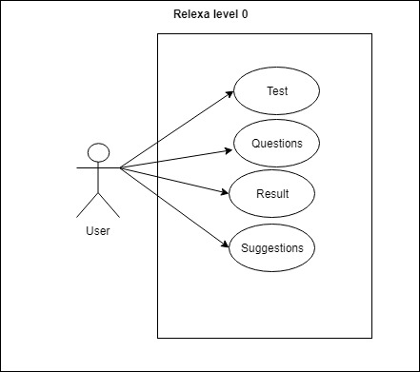

**Fig 4.1.1: Use Case for Level-0**

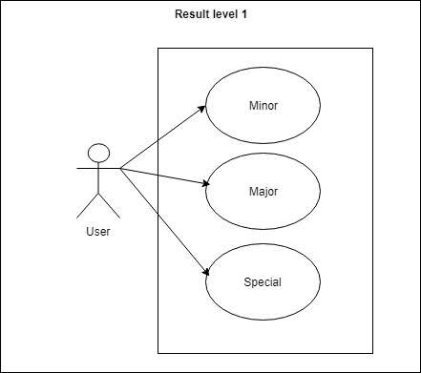

**Fig 4.1.2: Use Case for Level-1**

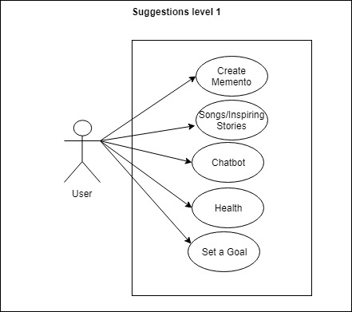

**Fig 4.1.3: Use Case for Level-1**

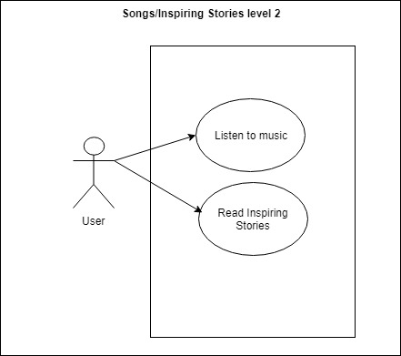

**Fig 4.1.4: Use Case for Songs /Inspiring stories Level-2**

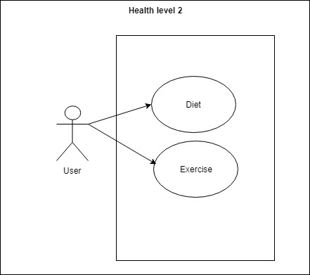

**Fig 4.1.5: Use Case for Health Level-2**

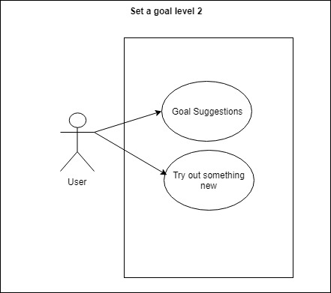

**Fig 4.1.6: Use Case for Set a goal Level-2**

**4.2 Activity Diagram:**

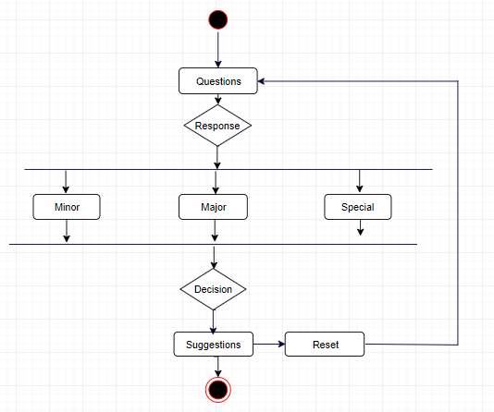

**Fig 4.2.1: Activity Diagram Level-0**

**Create Memento Module:**

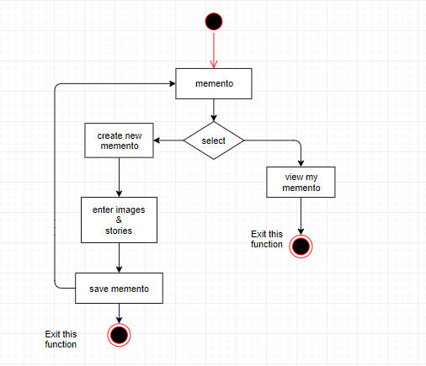

**Fig 3.2.2: Activity Diagram for Create Memento**

**Songs and stories:**

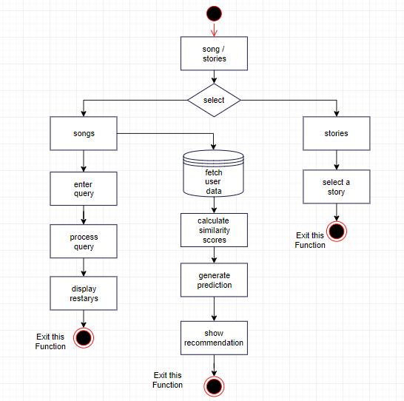

**Fig 4.2.3: Activity Diagram for Songs and stories**

**Set a Goal or Try out Something New:**

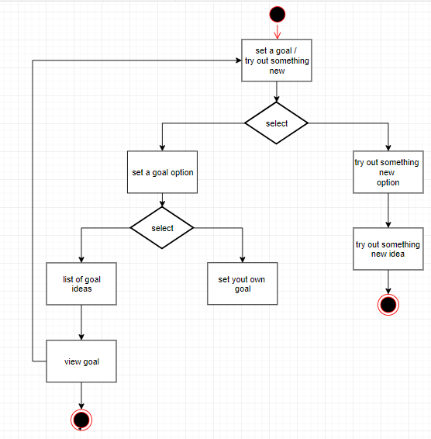

**Fig 4.2.4: Activity Diagram for Set a Goal or Try out Something New**

**Health Module:**

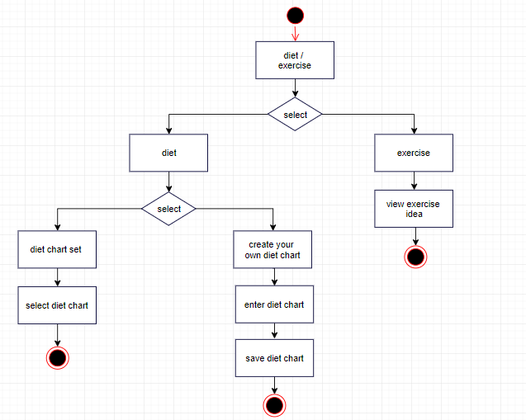

**Fig 4.2.5: Activity Diagram for Health Module**

**ChatBot Module:**

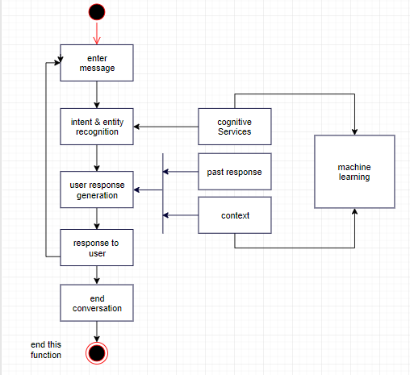

**Fig 4.2.6: Activity Diagram for ChatBot Module**

**4.4 Swim-lane Diagram**

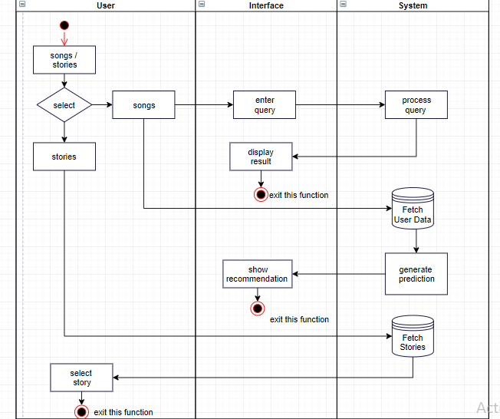

**Fig 4.4.1: Swim-lane Diagram for Songs and stories**

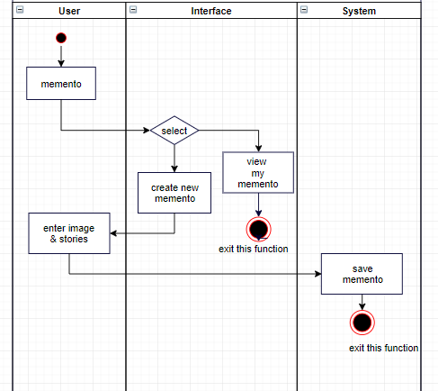

**Fig 4.4.2: Swim-lane Diagram for Create Memento**

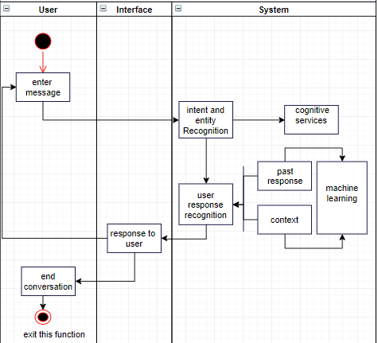

**Fig 4.4.3: Swim-lane Diagram for Chatbot**

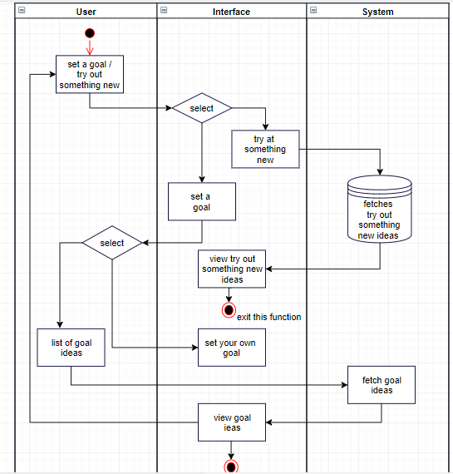

**Fig 4.4.4: Swim-lane Diagram for Set a goal**

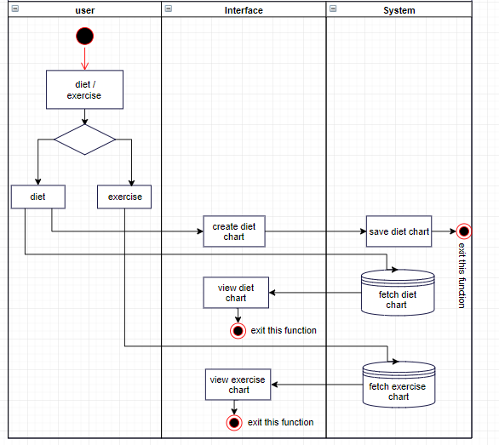

**Fig 4.4.5: Swim-lane Diagram for Diet and exercise**

**4.5 ER Diagram**

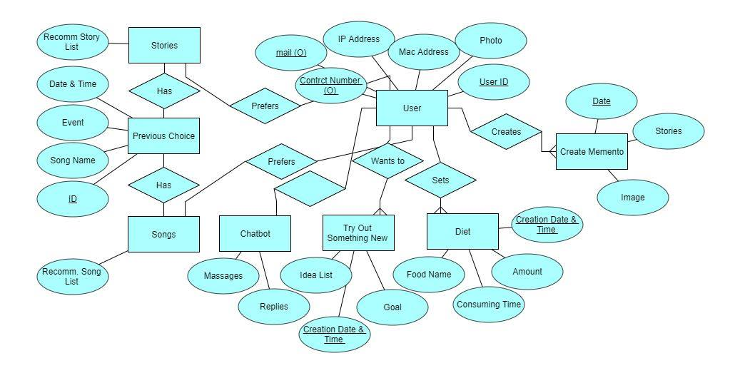

**Fig 4.5.1: ER Diagram**

**4.6 Class Responsibility Collaboration**

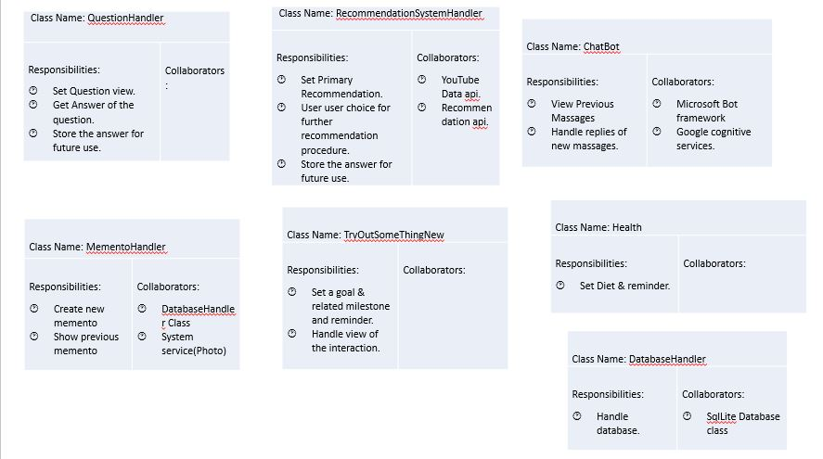

**Fig 4.6.1: CRC**

**4.7 Data Flow Diagram**

